Lab – 5

**Inheritance:** Derived Class declaration, Public, Private and Protected Inheritance, friend function and Inheritance, Overriding member function, Forms of inheritance, virtual base class, Abstract class, Constructor and Inheritance, Destructor and Inheritance, Advantage and disadvantage of Inheritance.

1. Write a simple base class, then a derived class and use objects of both of them in the main function. It will be a simple illustration of inheritance.
2. Practice protected access specifier in inheritance. In the base class declare a variable which is protected and access it in the derived class.
3. Most of the time we use public mode of inheritance, for example *class Derived: public Base{};*  Try protected and private access modifiers to understand the difference of various modes of inheritance.

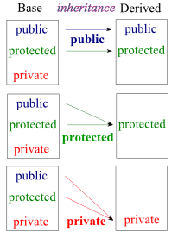

1. Write a C++ program to practice (i) friend function (ii) friend class.
2. Illustrate the application of overriding the base class function through the derived class member function.
3. Various types of inheritances are as shown below. Write small C++ codes for each inheritance type.

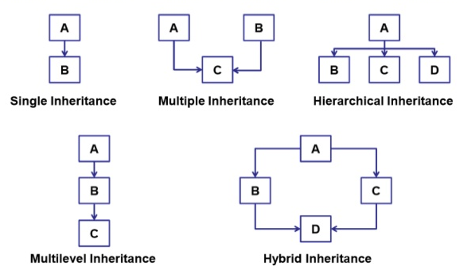

1. Write a program to create a virtual function in the base class and override (define) it in the child class.
2. What is an abstract class? Write a program to illustrate and discuss with the lab instructor.
3. How can you override constructors and destructors in C++ inheritance? Write a program to illustrate.
4. Discuss the advantages and disadvantages of inheritance in the lab.